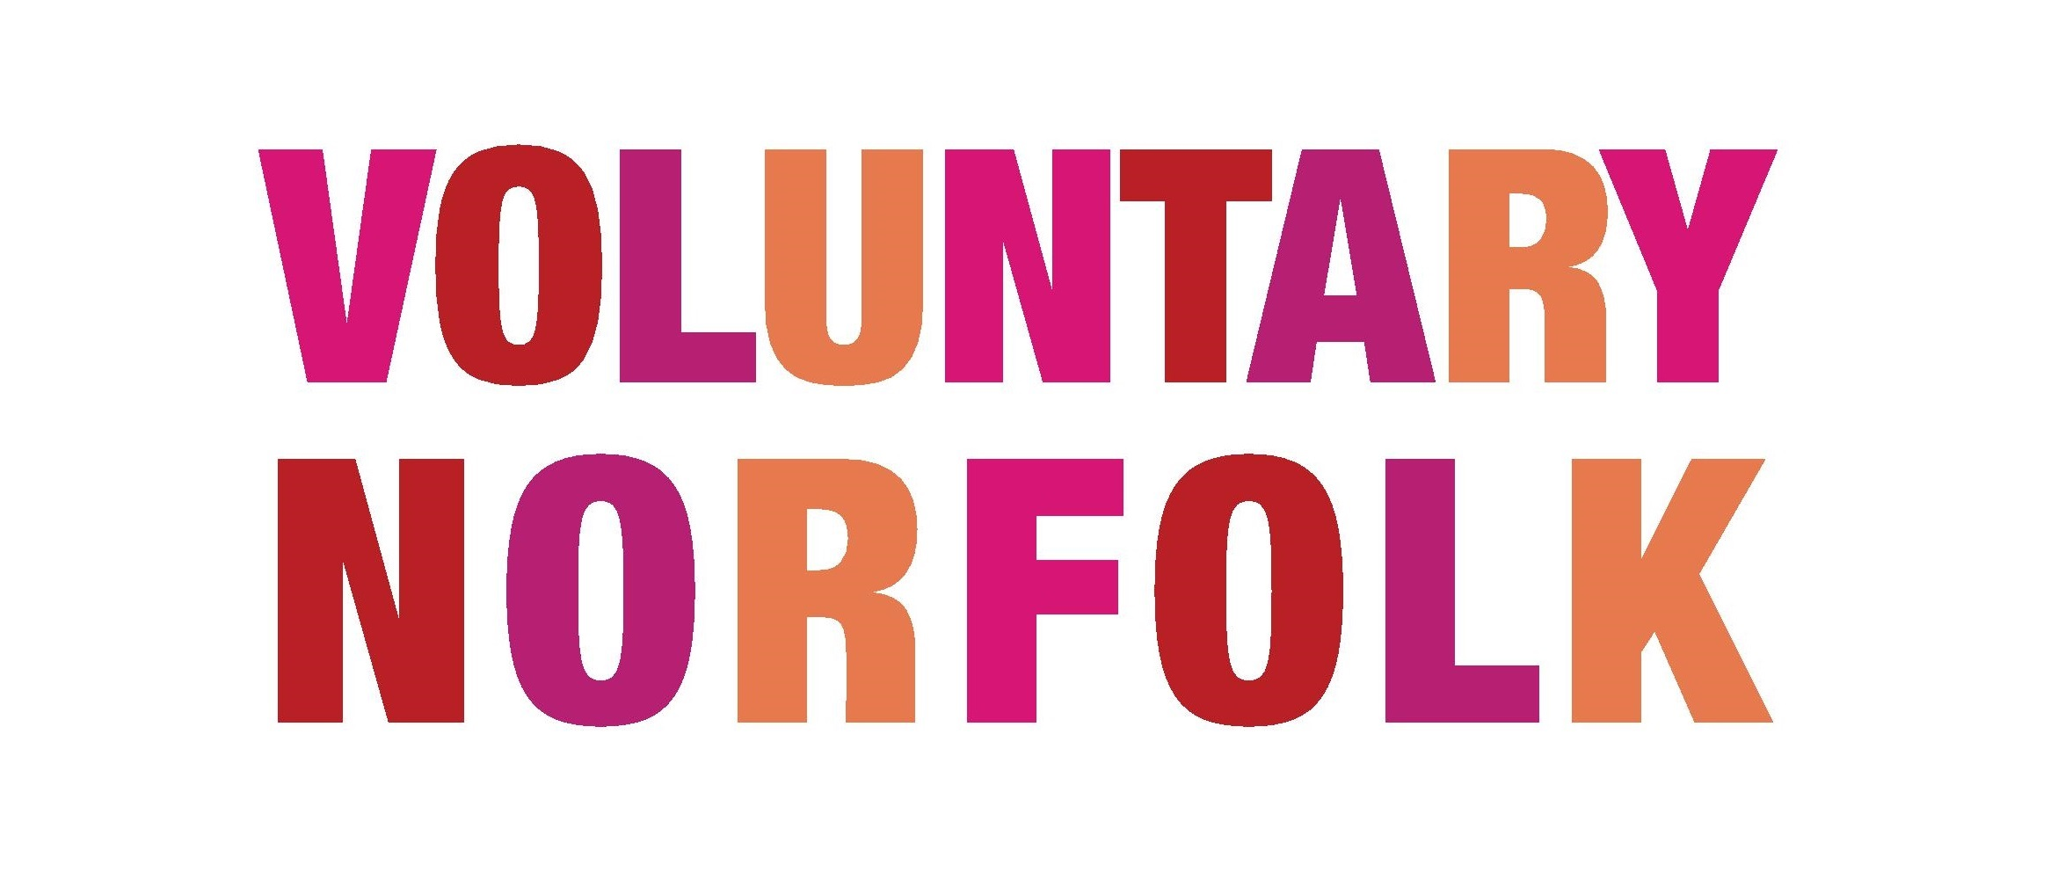

Legal Issues when Involving Volunteers

Volunteers are not covered by the same rights as paid employees, but as an organisation involving volunteers you have a duty of care, and a moral responsibility, to make sure that your volunteers are not exposed to any harm when in your service. Here are a few factors that you might like to keep in mind when involving volunteers -

Health and Safety

Health and Safety legislation is designed to protect employees, contractors, members of the public (e.g. users of the employer’s premises) and volunteers. Committee members of all voluntary organisations must ensure that their organisation complies with Health and Safety at Work legislation. The committee cannot rely on the staff to ensure their own health and safety. The primary legal responsibility remains with the committee as the employer.

The major instrument of health and safety legislation in the UK is the Health and Safety at Work Act 1974. This, and subsequent legislation, makes clear your duties to your employees. It also lays down further responsibilities on you in relation to people who are not your employees, including volunteers, who may be affected by your work activities.

It is strongly advised that you create a Health and Safety policy. It will demonstrate your commitment to the issues, make clear the areas of responsibility and lay down procedures and practices. This should specifically refer to your employees, volunteers, contractors, and members of the public who may be visiting your premises.

For more information on Health and Safety, check out the Health and Safety Executive – www.hse.gov.uk

Risk Assessments

As an employer, you must assess risk to your employees, and also anyone who might be affected by their activities. Volunteer roles should have written risk assessments, and action should be taken on the findings where necessary. Risks can typically be reduced by providing information, training, further supervision and by provision of any necessary safety protection. And for any events that your volunteers may be involved in (whether these are promotional or fundraising, or any other events) you will need to make sure that there are risk assessments in place.

You can receive a free Health and Safety Policy and Risk Assessment template from the Health and Safety Executive website – www.hse.gov.uk

Insurance

Volunteers should be covered by insurance, just like employees. Your insurance may not automatically cover volunteers and it may also specify upper and lower age limits. You will need to ensure that all volunteers are covered by your insurance policies before they start. Although this is not a legal requirement, it is advisable so that an organisation does not make themselves liable to negligence claims by volunteers. There are two main insurance policies which will be useful for covering volunteers are Public Liability and Employers Liability Insurance.

Data Protection

All information you hold about your volunteers must be kept under the terms of the Data Protection Act. You should only hold information on your volunteers which is necessary for their involvement in your organisation’s work, and for times of necessity (e.g. Next of Kin). You must fully explain to the volunteer the reason for collecting the information. You must only use the information for the purposes for which it was collected.

Personal information must be securely kept, and access to it should be restricted to relevant parties only. Information should only be kept for as long as its original purpose is valid, and in line with data protection guidelines. When no longer required, the information must be either destroyed (shredded) or handed back to the volunteer.

If a volunteer has access to confidential information they should also know about the Data Protection Act and how they should treat and store sensitive information.

You can access lots of information on the Data Protection Act here - https://www.gov.uk/data-protection/the-data-protection-act

Copyright

Copyright normally belongs to the person who creates work, but the law says that material created by employees is owned by their employer. The law does not explicitly state who owns the work created by volunteers under instruction of an organisation, therefore volunteers are still the owners of their own work. So if a volunteer writes an article for your newsletter, takes a photo that you use on your website, or draws an illustration for your Annual Review, for example, you need to ensure that the volunteer transfers copyright to your organisation or you confirm a licence where the work can be used under certain conditions.

For more detail than is briefly given here, you can buy or download a copy of “Volunteers and the Law” by Mark Restall from Volunteering England (www.volunteering.org.uk).

If you would like more information regarding volunteer management, get in touch with Voluntary Norfolk at volunteercentre@voluntarynorfolk.org.uk.

