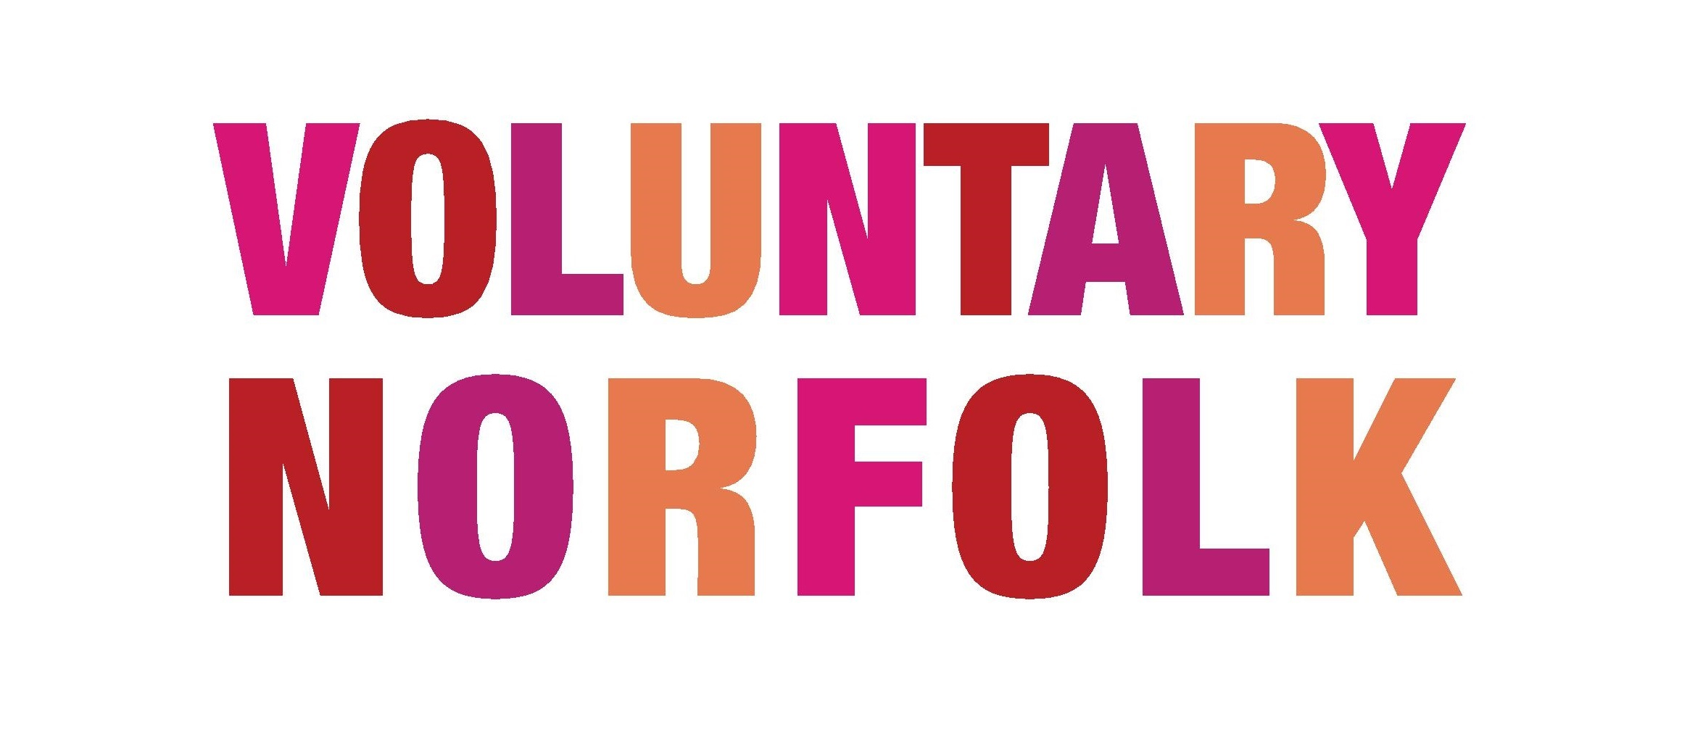

Volunteer Policies

What is a volunteer policy?

A volunteer policy is a document setting out the principles in how your organisation values and works with volunteers. It has some important implications for your work, namely -

It will demonstrate your commitment to volunteering
- It will help to ensure fairness and consistency in your volunteer programme
- It will tell the volunteers and employees of your organisation how a volunteer should expect to be treated, and demonstrate the difference between paid staff and volunteers
- It will be a point of reference for volunteers, and make them feel valued within the team

The best time to write a volunteer policy is at the very beginning, even before the first volunteer is in post. Then on a regular basis the policy should be reviewed and amended as needed, ideally with consultation from across the organisation, including the volunteer pool itself. We know that by including volunteers in this process they will feel valued.

The policy should be readily available to all staff and volunteers of your organisation. It is good practice to have copies printed out to give to new volunteers and staff, so that they can keep it and refer to it as and when needed.

What should it include?

There is no set format or rules for what should be included in a Volunteer Policy, or as some may call it, a Volunteer Involvement Policy. The document is not a legal one and therefore should be written in plain, understandable language. It should be able to demonstrate practically what the volunteer-organisation relationship is, but does not need to include everything and every scenario that may occur. After all, it should be a working document that people will actually read! You can always refer to other policies that your organisation uses if that is appropriate.

One factor to keep in mind is that some volunteers may not find this document to be the most accessible way to receive this information. ALL volunteers who are involved in your organisation should have access to this document and thus you may need to provide it in other languages, fonts, colours, and formats. Ask the volunteers what they need, to make sure that they are not missing out.
Below is a list of things you may like to include in your Volunteer Policy:

1. Introduction & Principles for Volunteer Involvement

Start with an explanation of the organisation, what it does and how it includes (or will aim to include) volunteers, and why. You may also like to include in this first section a line or two about the difference between paid staff and volunteers.

2. Recruitment

Stating how you aim to recruit volunteers would be useful in this policy. This may cover application forms, interviews, references, DBS checks and what you will do if someone is not appropriate for a volunteer role. Will your organisation use volunteer agreements? And explain the use of volunteer role descriptions.

3. Induction and Training

Describe here how you aim to train the volunteers to make sure they have the skills needed to thrive in their post. Will there be a trial period for new volunteers? What paperwork is in place for inductions and training?

4. Support

What support and supervision will be in place for volunteers? Who will manage them in post? For longevity of the policy you may like to avoid naming individual people and rather state their post such as the Volunteer Coordinator, or Shop Manager.

5. Expenses

Volunteers need to know how and when they can claim out of pocket expenses from the organisation, and for what activities. This is an opportunity to be as exhaustive as possible. State all of the situations when volunteers will be reimbursed (travel to and from volunteering, meals and refreshments, child care, etc) and if there are any upper monetary limits on claims. State where volunteer expenses forms can be found, and give an idea of the frequency at wish you would like volunteers to claim (for example once a week or month).

6. Insurance

Before volunteers are involved in the organisation they should be covered by insurance. They will be covered by either public or employers’ liability cover. Give details of this insurance document.

More information on insurance can be found on the NCVO website Insurance and volunteers — NCVO Knowhow

7. Equal Opportunities / Diversity

It will be useful to add in a few lines about diversity, and how your organisation ensures that no one is excluded from volunteering though discrimination. You may like to add a link to your more thorough Diversity Policy.

8. Health and Safety

Your organisation will have a duty of care to avoid exposing volunteers to risks related to health and safety. Point volunteers to your Health and Safety Policy for further information. more information on Volunteer Health and Safety can be found on the HSE website Volunteering: How to manage the risks - HSE

9. Problems, Grievance and disciplinary procedures

What plans do you have in place for any problems that may occur? What if a volunteer has a problem with you? What if you have a problem with the volunteer? For this section you may not wish to refer to the wider organisational policy, as it will be specifically for paid staff. However, even though volunteers are not covered by the law in the same way, it is worth having a fair and transparent system in place for dealing with volunteer complaints and disciplinary procedures.

10. Confidentiality

Some volunteers in certain roles may have access to a lot of private or personal information. Volunteers need to be made aware that they will be bound by the same requirements as volunteers when it comes to confidentiality.

11. Endings

What will happen when a volunteer leaves post? Will there be an exit interview? How will they be thanked? Will a reference be provided, and by who?

12. Review

When did you make this current version of the policy, and when will it be due to be reviewed next?

For further information about Volunteer Policies, you can find further information on the NCVO website Policies and procedures — NCVO Knowhow

If you would like more information regarding volunteer recruitment, get in touch with us at volunteercentre@voluntarynorfolk.org.uk

