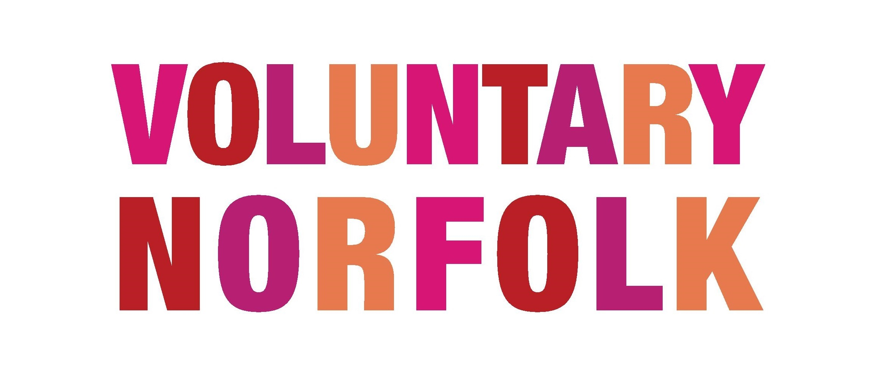

Volunteer Role Descriptions

A volunteer role description is so important in recruiting volunteers, particularly in attracting the right volunteers. This will be the first document that will give prospective volunteers an idea of your organisation – the culture, the style, the professionalism, and the values you hold about volunteering. It will be the first chance for the volunteer to make an informed decision about whether they feel like they fit the criteria of the role.

A separate volunteer role description should be made for each role. This may seem like a lot of work, but once you have your template in place, then it will be quick and easy to create new documents.

Tips for making a great role description:
- Make the document clear and concise
- Be honest about your expectations of the volunteer, and what skills or experience they will need
- Avoid terms that may be considered to be legal employment terms (hence why we say Role Description, not Job Description)
- Remember to include what the volunteer will gain from volunteering, as well as your expectations of them
- Make the document look ‘official’. Include your logo, and links to your website. This will show you are serious about volunteering, and value volunteers.
- Remember that volunteers may be looking at a few different role descriptions, possibly from different organisations, so make sure yours stands out!

It is best practice to regularly review your volunteer roles, and the role descriptions. A great way to do this is to ask any volunteers currently in the role to help to evaluate whether the role description is accurate, or any volunteers who are leaving the role. You may consider: Are there any duties or activities missing? Has the contact person changed? Is there a more dynamic or appropriate role title? Keeping the role description up to date and accurate will ensure that you are attracting the right volunteers, and managing the expectations of anyone who applies to volunteer.

You will find a template role description on the next page.

Template Volunteer Role Description

Name of Role:
A great snappy role title which will set the tone for the role. If possible, avoid using the word ‘Volunteer’ in the title, as it is understood that the role is voluntary.

About the organisation:
Include a few lines about your organisation with a link to your website or social media sites so that volunteers can research more. Also, if possible in one sentence, highlight how this role fits into the organisation.

About the role:
This is your chance to set our your expectations of the volunteer, outline what they will do in post, and also let them know what they can expect to gain in return. You may include, if appropriate -
- A list of duties, activities or main tasks
- Times and frequency of volunteer involvement (ie. Every Thursday afternoon, or once a month)
- The location of the role
- The skills they will learn, any training they will receive or any real selling points
- You may like to outline the kind of person who may be interested in the role (ie. A perfect role for someone looking to gain experience in customer service)

Skills / experience needed:
This is where a volunteer can see whether they are suitable for the role. Although it is very tempting to undersell the skills and experience needed for a role to attract more volunteers, ultimately the role description should attract the right volunteer. So if a skill is non-negotiable (such as communication skills, computer skills, driving skills, etc) then it is definitely better to list this in the role description.

Contact details:
Remember the contact details of the Volunteer Coordinator, or someone who will be able to tell the volunteer more about the role, or the organisation. Listing both telephone number and email address and a specific person to speak to would be ideal. It may also be worth noting if the contact works part-time or if it sometimes takes a little while to reply, just so that the volunteer is not left wondering.

If you would like more information regarding volunteer recruitment, get in touch with us at volunteercentre@voluntarynorfolk.org.uk

