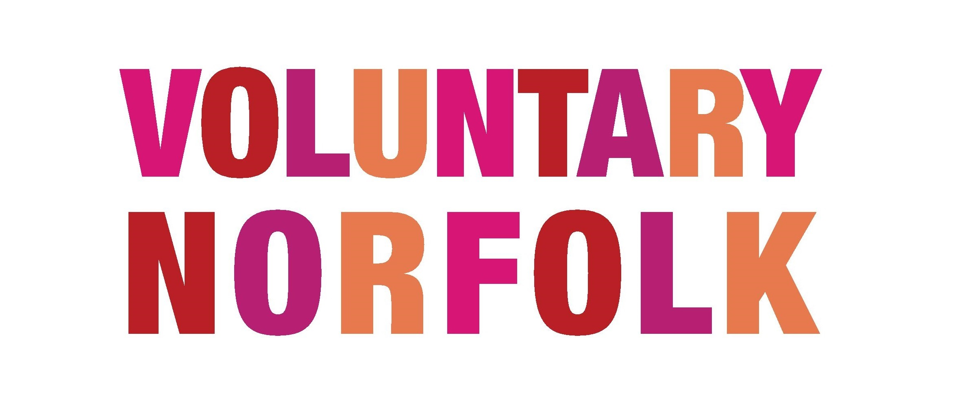

Inducting & Training Volunteers

Just like a paid employee in post, your volunteers need to feel confident that they have all the information and resources they need, in order to carry out their tasks for your organisation or project. Best practice in Volunteer Management dictates you should provide the training your volunteers need, which begins with an induction, followed by either informal or formal training.

Induction

Induction of new volunteers is a form of training, and the start of an ongoing process. There is a lot of information which the new volunteer needs in order to be able to do their tasks, and it can be overwhelming at first. You need to separate the things they need to know now from the things they need to know later. You might like to draw up a volunteer induction checklist, especially if you might be taking on several new volunteers, and to make sure you cover everything needed. If you regularly take on new volunteers, you could produce a Volunteer Induction Pack.

Training

This might be informal, such as a new volunteer shadowing an experienced volunteer, or having an experienced volunteer as a ‘buddy’ or mentor. Or it may be formal, with the volunteer attending a training course, put on by your own organisation or another. You might provide volunteers with a volunteer manual, checklist for working in certain situations (lone working; visiting people in their own homes; etc.), or operations procedures (‘how to do it’ for their tasks). Make sure they have access to all relevant policies, including the Volunteer Involvement Policy. Training is for experienced volunteers, as well as new ones. Training keeps volunteers fresh, motivated and aware of the organisation’s aims, standards, effects on the service users and the volunteers’ reasons for helping.

Note about training. – You should only provide training which the volunteer needs in order to carry out their tasks or to prepare to take on new tasks. If you provide training which the volunteer wants, but which is not of use to them in their volunteering with you, then the HM Revenue & Customs would regard that as a ‘benefit in kind’, and would want the volunteer to pay income tax on the commercial cost of the training. If you do this for a volunteer who is on benefits, you will cause them similar problems.

If you would like more information regarding volunteer management, get in touch with Voluntary Norfolk at volunteercentre@voluntarynorfolk.org.uk

