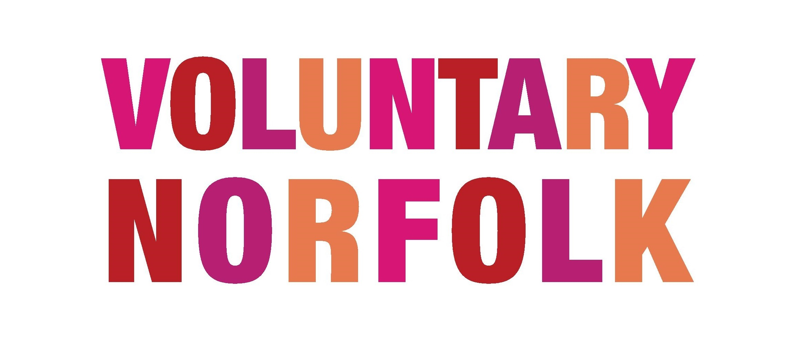

Selection,
Safeguarding & DBS

Safeguarding in your organisation may take many different guises, so this Information Sheet is designed to make you think about safeguarding your volunteers, clients and your organisation, particularly related to volunteer management.

Volunteer Selection

Choosing the right volunteer for a role is the first line of defence when it comes to safeguarding. You need to make sure that the right volunteer, with the right skills, is in post. Here are some ways you can ensure that you have the right volunteer:

- Application form
Ask the potential volunteer to fill out an application form where they can let you know about their experience and skills
- References
Ask the volunteer to give you two character references. If a volunteer can not provide you with two character references, this in effect means that they cannot name two people who will say they are a good person. This can say a lot about them.
- DBS check
If the volunteer will be working with vulnerable adults or children they will need a DBS check, more details on this below.
- Observation of volunteer in induction, training and in role
Do not underestimate the power of ‘going by your gut instinct’ or the way a volunteer interacts through training or induction
- A trial period
You may like to give volunteers a trial period where they are shadowing another volunteer in post or are very well supported. How they perform under this trial period will tell you a lot about their suitability.

Of course, all of these selection criteria may not be needed. It will very much depend upon the role. For example, a volunteer who will be helping on a one-off conservation project planting some trees will need a much more relaxed, informal selection process, compared to a volunteer who will befriending and visiting elderly people in their own home unsupervised. Always keep in mind the role and the expectation of the volunteer.

Remember: the need to safeguard and select the right volunteer for each role is to protect your organisation, your clients and the volunteer themselves.

Disclosure and Barring Service (DBS)

The DBS check system has replaced what used to be CRB checks. Although there is a new name, and a new system, the same principles in terms of who should be police checked remain the same.

Police checks should be carried out on any staff or volunteers who will be working unsupervised with vulnerable people or children. But be aware, it is illegal to ask to use the Disclosure and Barring Service on someone who is not going to be in a role where they are working unsupervised with vulnerable people or children. It is an invasion of their privacy, and not to mention a waste of time and resources!

Voluntary Norfolk provides a DBS checking service for employers and volunteer managers. For more information, please follow this link - http://www.charitybackroom.org.uk/crb-checks-id-badges-

In addition, as a volunteer manager, you should be aware of placing volunteers in risky situations. Volunteers who will be working with vulnerable people or children, will need to understand about safeguarding and how that can be applied to their role. As a volunteer manager you will not want to put volunteers in an environment where they are vulnerable themselves. For example if you have adult volunteers who are working with you (whether they are, or are not DBS checked), if avoided it is best not to leave them in a situation where they are volunteering alone with another volunteer who is under 16. This is not always possible, but it is something to keep in mind.

Safeguarding awareness and training

Volunteers also may come up against situations when they question the safety of the clients they are working with. If your organisation works with vulnerable people or children, you will need to ensure that the volunteer is knowledgeable on how to raise this issue with staff at your charity. For example, what would a volunteer befriender for older people do if they had a suspicion that a carer is abusing their befriended? Would they know who to speak to at the organisation? Would they know that it is their duty to report such a suspicion? It would be good practice to appoint a staff member to take lead on safeguarding issues that may arise. They may have received formal SAFE training or have previous experience of this. The volunteers should know who this appointed person in your organisation is for any safeguarding concerns they may have. Specialist training can be ‘bought in’ on this subject. Speak to Voluntary Norfolk for more information.

If you would like more information regarding volunteer management, get in touch

volunteercentre@voluntarynorfolk.org.uk .

